Modifying Security Permissions On Mac.

When Installing JMP in Mac Mountain Lion OS X10.8 or higher you may see the following error message : Your security preferences allow installation of only apps from the Mac App Store and identified developers.

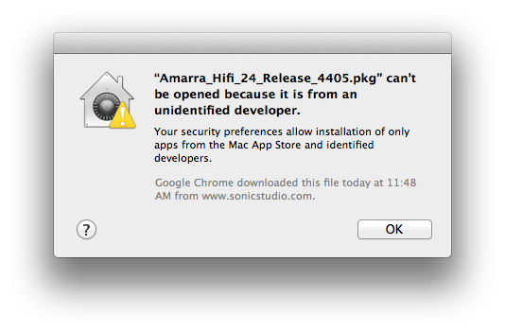

Please follow the instructions below to enable out of store application installation for JMP install.

1. Launch **System Preferences** and click on it.

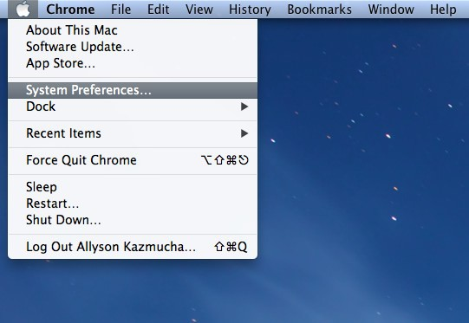

1. From here click on the **Privacy & Security** icon in the top row.

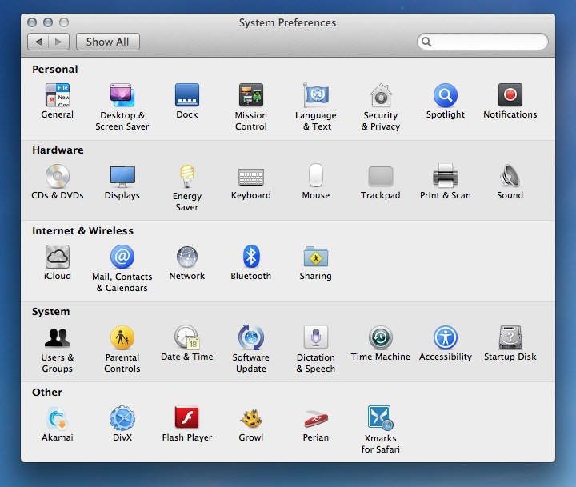

1. The **General** tab is where we want to be.
2. If everything is grayed out, click on the lock in the bottom left hand corner and type in your administrator password. This will allow you to make changes to your settings.

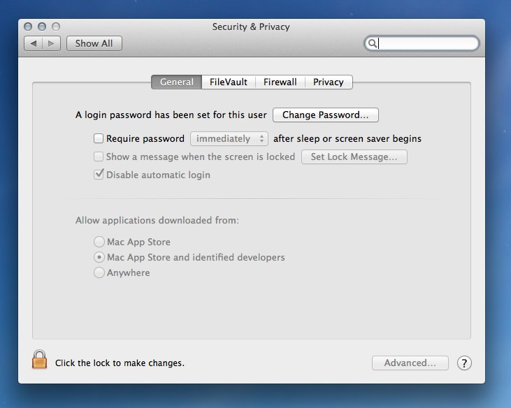

1. **Anywhere** which will allow any app to be opened regardless of the source or developer.

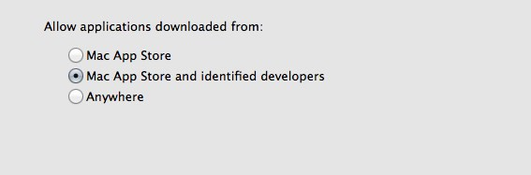

Once you've made your changes you can go ahead and install JMP on your laptop.